2025

Charell Owings
United Way of Central Kansas
620-792-2403
unitedwaycentralks@hotmail.com
www.uwck.org
PO Box 1742
2000 Washington St
Great Bend, KS 67530

FUNdraising Idea Guide

Your one stop shop for creative workplace fundraising ideas and how to increase giving in your Workplace Campaign.
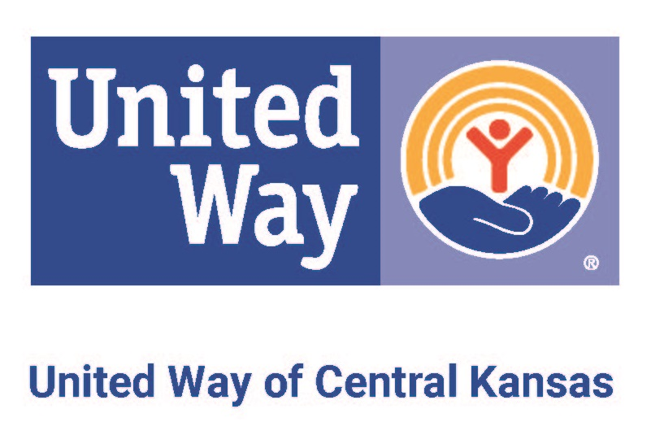
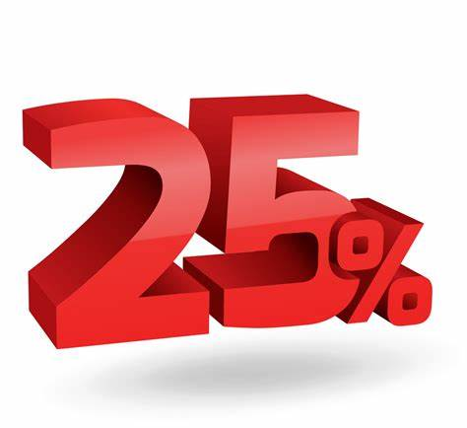

Incentive Ideas

Free Oil Change | Gift Certificates | Golf with the Boss
Lottery Tickets | Tickets to sporting event | Open soda/candy machines
Pizza Party | Reserved parking | Vacation Day
“Flee at 3” coupon | Car wash | Casual day
Company swag | Ice Cream Day | Pie the Boss

PAIGN GAME PLAN

Contests and Prizes
- Sponsor a contest between departments. Most participation or highest per capita giving wins! Offer lunch on the boss or an ice cream treat day.
- Offer prizes to participants through a raffle. To earn a ticket, you can return your pledge form (1 ticket), increase giving from prior year (1 ticket), or be a new participant (1 ticket).

Increase Workplace Giving
MPAIGN GAME PLAN

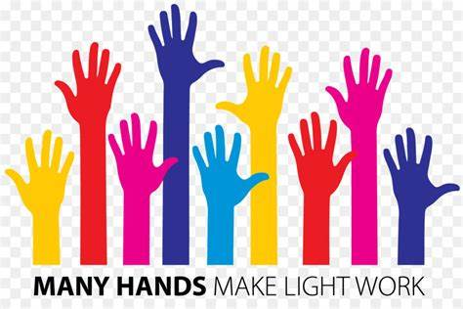
PAIGN GAME PLAN

Implement a Fair Share Program
- Encourage employees to give their Fair Share-25% of 1 hour pay each pay period.
  - For example, they make $15/hr, their contribution per two week pay period is $3.75. The power of the incentive is that it gets everyone contributing and doing so with a happy heart! If payroll period is monthly, you would adjust that to a higher percentage.
  - Those who give their Fair Share get a bonus day off!

Set an Example
- Offer a Corporate Match. This can range from a dollar-to-dollar match to $1 per pay period for every person that donates.
- Encourage volunteerism. Offer employees a day off if they are volunteering in the community.
- Sponsor an event. Not only will you get recognition publicly, but your employees will know you care and that you are doing your part.

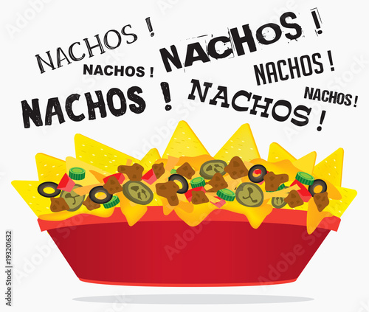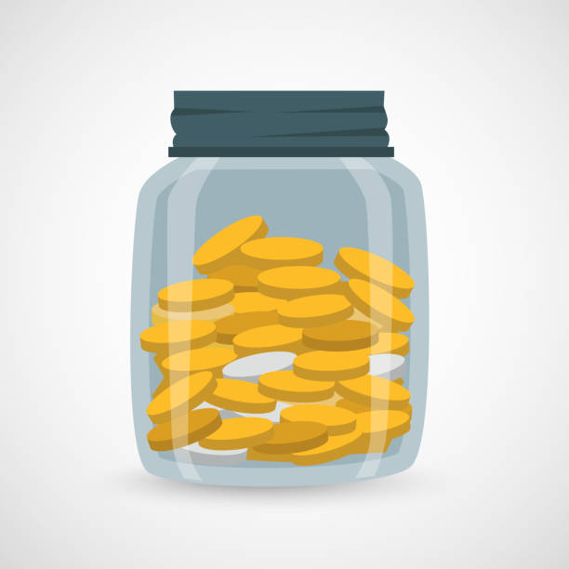
PAIGN GAME PLAN

- Jar Wars - Have a friendly competition by putting jars around the office for different departments to donate their spare change. The team whose jar has the most money at the end wins a prize.
- Candy Count - Send out a picture of a jar stuffed with candy. Charge a small donation to guess the count. Winner gets the candy!
- Golf Putt - Supply a putting green and club. Employees pay per putt for a chance to win prizes.
- Balloon/Candy Grams - Sell balloons or candy with notes of recognition and appreciation.
- Decorating contest - Decorate pumpkins, rocks, whatever you can think of. Vote for the best with a small donation. Winner splits the total with United Way.
- Host a coffee cart, nacho bar, or a root beer float stand. Charge a flat fee with proceeds benefiting United Way.

Workplace Fundraisers

