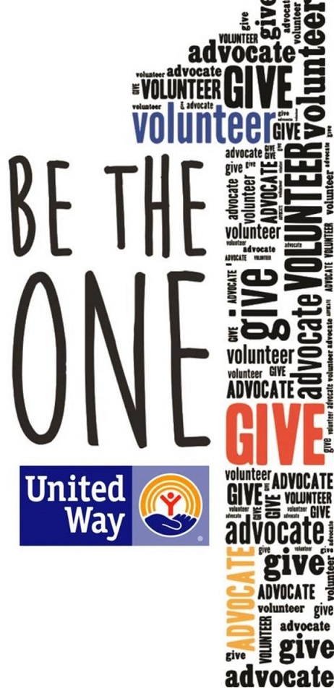
I love the United Way campaign, but let’s be honest: some of you still have questions. Where does the money go? Does my donation really make a difference?
The short answers are: where it’s most needed and ABSOLUTELY!
But let me break it down for you:
Where does the money go?
All donations to United Way benefit people in Central Kansas and support access to quality education, a stable income that can support a family, and good health.
Some initiatives – like Dolly Parton’s Imagination Library, Literacy Kits, Boxes of Love, Born Learning Trails, Reality U, and Hands Only CPR. Not to mention the financial support that UWCK
Does my donation make a difference?
Absolutely! You might be amazed by how much good each dollar does.
For example:
· For $5 a month you can provide a Box of Love to a dozen homebound seniors.
· For $10 per month you can provide Literacy Kits to a classroom of Pre-K students.
· For $25 a month you can provide food for a family for a month through the Hoisington Food Bank.
· For $40 a month you can provide services to an at-risk youth, helping to get them back on track to a successful future.
· For $80 a month you can provide a Meals on Wheels lunch to one person for a month.

By donating to United Way of Central Kansas, you can rest assured that your dollars are staying local and are going to agencies with a proven track record.

“Alone we can do so little; together we can do so much.”-Helen Keller

#LiveUnited #BeTheOne

